Functional Models – “Multi-Objective Decision Support System for Business Planning”
Bhasitha Ananthula, Systems Analyst
February 8, 2026

- Use Case Diagram
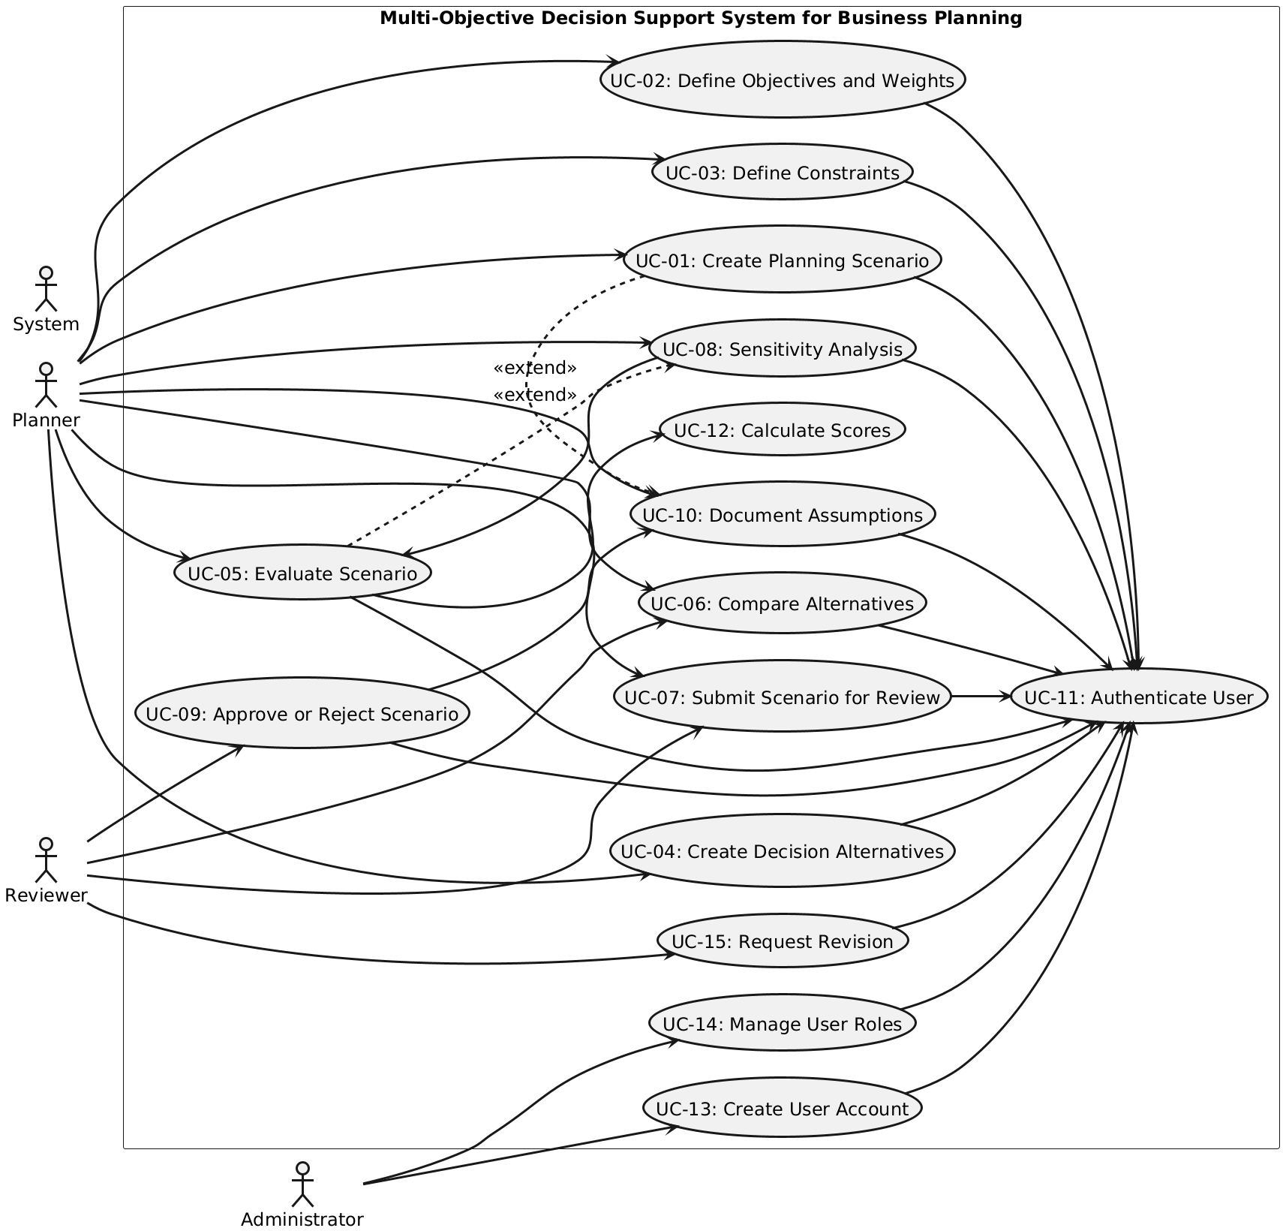

Diagram 1: Use Case Diagram for “Multi-Objective Decision Support System for Business Planning”
- Use Case Description
Use Case - 1
Use Case Name: Create Planning Scenario |  | ID:UC-1 | Importance Level: High
Primary Actor: Planner | Use Case Type: Primary
Stakeholders and Interests: Planner – Wants to create a new planning scenario to analyze business decisions in a structured and reusable way.
Organization – Wants planning decisions to be consistent, documented, and traceable.
Reviewer – Needs scenarios to be clearly defined before evaluation and approval.
Brief Description: This use case describes how a Planner creates a new planning scenario by providing a scenario name and description. The planning scenario serves as the container for objectives, constraints, alternatives, and evaluation results.
Trigger: The Planner selects the option to create a new planning scenario.
Type: External
Relationships:
Association: Planner
Include: UC-11 Authenticate User
Extend: UC-10 Document Assumptions
Generalization: None
Normal Flow of Events:
- The Planner initiates the creation of a new planning scenario.
- The system executes UC-11 Authenticate User to verify the Planner’s identity and role.
- The system prompts the Planner to enter a scenario name and description.
- The Planner enters the required scenario information.
- The system validates the entered information.
- The system creates and stores the planning scenario.
- The system confirms successful creation of the planning scenario.
SubFlows: S-1 Validate Scenario Information
- The system verifies that the scenario name is provided and unique.
- The system checks that the description meets defined format and length requirements.
Alternate/Exceptional Flows: Use Case Cannot Be Completed
- If authentication fails during UC-11 Authenticate User, the system terminates the use case and displays an access error message.
- If required scenario information is missing or invalid, the system displays an error message and requests the Planner to correct the input before continuing.

This use case description covers the following requirements: 1, 38, 2, 3, 4, 14.
Use Case - 2
Use Case Name: Define Objectives and Weights |  | ID:UC-2 | Importance Level: High
Primary Actor: Planner | Use Case Type: Primary
Stakeholders and Interests: Planner – Needs to define objectives and assign weights to reflect business priorities within a planning scenario.
Organization – Requires objectives to be clearly defined and consistently weighted to ensure transparent and repeatable decision analysis.
Reviewer – Needs visibility into defined objectives and weights to evaluate the validity of scenario results.
Brief Description: This use case describes how a Planner defines one or more objectives for an existing planning scenario and assigns numeric priority weights to each objective. These objectives and weights are used by the system during scenario evaluation.
Trigger: The Planner selects the function to define objectives for a planning scenario.
Type: External
Relationships:
Association: Planner
Include: UC-11 Authenticate User
Extend: None
Generalization: None
Normal Flow of Events:
- The Planner selects an existing planning scenario.
- The system executes UC-11 Authenticate User to verify the Planner’s identity and role.
- The system displays the list of objectives currently associated with the scenario.
- The Planner defines a new objective or selects an existing objective to modify.
- The Planner assigns a numeric priority weight to each objective.
- The system validates the objective definitions and weight values.
- The system saves the objectives and weights for the planning scenario.
- The system confirms that the objectives and weights have been successfully updated.
SubFlows: S-1 Validate Objective Weights
- The system verifies that each objective weight is within administrator-defined limits.
- The system ensures that objective definitions are complete and uniquely identified within the scenario.
Alternate/Exceptional Flows: A-1 Use Case Cannot Be Completed
- If authentication fails during UC-11 Authenticate User, the system terminates the use case and displays an access error message.
- If objective definitions or weight values are missing or invalid, the system displays an error message and requests the Planner to correct the input.
This use case description covers the following requirements: 2, 3, 32, 40, 6, 14.
Use Case - 3
Use Case Name: Define Constraints |  | ID:UC-3 | Importance Level: High
Primary Actor: Planner | Use Case Type: Primary
Stakeholders and Interests: Planner – Needs to define constraints (e.g., budgets, resource limits) to ensure feasible planning scenarios.
Organization – Requires constraints to be clearly defined to maintain consistent and valid decision analysis.
Reviewer – Needs visibility into constraints to evaluate whether scenario alternatives comply with organizational limits.
Brief Description: This use case describes how a Planner defines constraints for an existing planning scenario. Constraints restrict feasible solutions and ensure that alternatives comply with business rules, budget limits, and resource availability.
Trigger: The Planner selects the function to define constraints for a planning scenario.
Type: External
Relationships:
Association: Planner
Include: UC-11 Authenticate User
Extend: None
Generalization: None
Normal Flow of Events:
- The Planner selects an existing planning scenario.
- The system executes UC-11 Authenticate User to verify the Planner’s identity and role.
- The system displays the current list of constraints associated with the scenario.
- The Planner defines a new constraint or modifies an existing constraint.
- The Planner specifies acceptable value ranges or limits for each constraint.
- The system validates the constraints for consistency and completeness.
- The system saves the constraints for the scenario.
- The system confirms that the constraints have been successfully updated.
SubFlows: S-1 Validate Constraint Values
- The system checks that all constraint values are within allowed ranges.
- The system ensures that constraints do not conflict with existing objectives or other constraints.
Alternate/Exceptional Flows: A-1 Use Case Cannot Be Completed
- If authentication fails during UC-11 Authenticate User, the system terminates the use case and displays an access error message.
- If constraint values are missing, invalid, or inconsistent, the system displays an error message and requests the Planner to correct the input.
This use case description covers the following requirements: 4, 5, 40, 7, 14.
Use Case - 4
Use Case Name: Create Decision Alternatives |  | ID:UC-4 | Importance Level: High
Primary Actor: Planner | Use Case Type: Primary
Stakeholders and Interests: Planner – Needs to define multiple decision alternatives for a scenario to evaluate options effectively.
Organization – Wants alternatives to be well-defined to ensure structured and objective decision-making.
Reviewer – Needs clear alternatives to review and compare during scenario evaluation.
Brief Description: This use case describes how a Planner creates and manages decision alternatives within a planning scenario. Each alternative includes values for objectives, enabling the system to evaluate, rank, and compare them against constraints.
Trigger: The Planner selects the option to create or edit decision alternatives for an existing planning scenario.
Type: External
Relationships:
Association: Planner
Include: UC-11 Authenticate User
Extend: None
Generalization: None
Normal Flow of Events:
- The Planner selects an existing planning scenario.
- The system executes UC-11 Authenticate User to verify the Planner’s identity and role.
- The system displays any previously defined decision alternatives for the scenario.
- The Planner creates a new alternative or selects an existing alternative to modify.
- The Planner enters objective-related values for each alternative.
- The system validates the alternative data for completeness and compliance with defined constraints.
- The system saves the new or updated alternative.
- The system confirms that the decision alternative has been successfully created or updated.
SubFlows: S-1 Validate Alternative Data
- The system ensures that all required objective values are entered for the alternative.
- The system checks that values fall within acceptable ranges for each objective.
Alternate/Exceptional Flows: A-1 Use Case Cannot Be Completed
- If authentication fails during UC-11 Authenticate User, the system terminates the use case and displays an access error message.
- If required objective values are missing or invalid, the system displays an error message and requests the Planner to correct the input.
The above use case description covers the following requirements: 6, 7, 39, 14.
Use Case - 5
Use Case Name: Evaluate Scenario |  | ID:UC-5 | Importance Level: High
Primary Actor: Planner | Use Case Type: Primary
Stakeholders and Interests: Planner – Wants to evaluate all defined alternatives against objectives and constraints to make informed decisions.
Organization – Requires consistent, objective, and reproducible evaluation of planning scenarios to support business decisions.
Reviewer – Needs accurate evaluation results to verify scenario validity and assist in decision review.
Brief Description: This use case describes how a Planner evaluates a planning scenario. The system calculates scores for each alternative based on defined objectives, priorities, and constraints. The results provide a ranked list of alternatives to support decision-making.
Trigger: The Planner selects the option to evaluate a planning scenario.
Type: External
Relationships:
Association: Planner
Include: UC-11 Authenticate User, UC-12 Calculate Scores
Extend: UC-08 Sensitivity Analysis
Generalization: None
Normal Flow of Events:
- The Planner selects an existing planning scenario.
- The system executes UC-11 Authenticate User to verify the Planner’s identity and role.
- The system retrieves the defined objectives, weights, constraints, and alternatives for the scenario.
- The system executes UC-12 Calculate Scores to evaluate each alternative against objectives and constraints.
- The system generates a ranked list of alternatives based on calculated scores.
- The Planner reviews the evaluation results, including scores for each objective.
- The system stores the evaluation results for future comparison and reporting.
- The system confirms that the evaluation has been successfully completed.
SubFlows: S-1 Score Calculation Verification
- The system verifies that all alternative data is complete and valid before calculation.
- The system ensures that evaluation scores are consistent and reproducible.
Alternate/Exceptional Flows: A-1 Use Case Cannot Be Completed
- If authentication fails during UC-11 Authenticate User, the system terminates the use case and displays an access error message.
- If alternative data is incomplete or invalid, the system displays an error message and requests correction before proceeding.
This use case description covers the following requirements: 9, 10, 11, 12, 14, 5.
Use Case - 6
Use Case Name: Compare Alternatives |  | ID:UC-6 | Importance Level: High
Primary Actor: Planner | Use Case Type: Primary
Stakeholders and Interests: Planner – Wants to compare multiple decision alternatives to select the most suitable one based on objectives and constraints.
Organization – Requires clear comparisons to ensure that selected alternatives meet business goals and constraints.
Reviewer – Needs to verify that alternatives are evaluated and compared consistently before approving a scenario.
Brief Description: This use case describes how a Planner compares multiple decision alternatives within a planning scenario. The system presents evaluation results in a clear, organized format, highlighting trade-offs between objectives to support informed decision-making.
Trigger: The Planner selects the option to compare alternatives for an evaluated planning scenario.
Type: External
Relationships:
Association: Planner
Include: UC-11 Authenticate User
Extend: None
Generalization: None
Normal Flow of Events:
- The Planner selects an existing evaluated planning scenario.
- The system executes UC-11 Authenticate User to verify the Planner’s identity and role.
- The system retrieves evaluation results for all decision alternatives in the scenario.
- The system displays alternatives in a ranked or tabular format, showing objective scores and constraint compliance.
- The Planner compares alternatives and reviews trade-offs between objectives.
- The Planner may annotate or flag preferred alternatives for review or selection.
- The system confirms that the comparison results are saved for future reference.
SubFlows: S-1 Visualize Trade-Offs
- The system generates charts or graphs to illustrate differences between alternatives for each objective.
- The system highlights alternatives that violate any constraints for easier review.
Alternate/Exceptional Flows: A-1 Use Case Cannot Be Completed
- If authentication fails during UC-11 Authenticate User, the system terminates the use case and displays an access error message.
- If evaluation results are missing or incomplete, the system displays an error message and requests the Planner to run UC-05 Evaluate Scenario before comparing alternatives.
This use case description covers the following requirements: 15, 16, 11, 12, 17, 14.
Use Case - 7
Use Case Name: Submit Scenario for Review |  | ID:UC-7 | Importance Level: High
Primary Actor: Planner | Use Case Type: Primary
Stakeholders and Interests: Planner – Wants to submit a fully defined and evaluated planning scenario for review and approval.
Organization – Requires that scenarios are formally reviewed to ensure compliance with business rules and objectives.
Reviewer – Needs access to complete scenarios to evaluate and provide approval, feedback, or request revisions.
Brief Description: This use case describes how a Planner submits a completed planning scenario, including objectives, constraints, and decision alternatives, to a Reviewer. Submission triggers the review process for approval, feedback, or revision requests.
Trigger: The Planner selects the option to submit a planning scenario for review.
Type: External
Relationships:
Association: Planner
Include: UC-11 Authenticate User
Extend: None
Generalization: None
Normal Flow of Events:
- The Planner selects an evaluated planning scenario.
- The system executes UC-11 Authenticate User to verify the Planner’s identity and role.
- The system checks that all required elements (objectives, constraints, alternatives, evaluations) are complete.
- The Planner confirms submission of the scenario.
- The system marks the scenario as submitted and notifies the assigned Reviewer.
- The system confirms successful submission to the Planner.
SubFlows: S-1 Verify Scenario Completeness
- The system ensures that the scenario contains objectives, constraints, decision alternatives, and evaluation results before allowing submission.
- The system prompts the Planner to complete missing elements if required.
Alternate/Exceptional Flows: A-1 Use Case Cannot Be Completed
- If authentication fails during UC-11 Authenticate User, the system terminates the use case and displays an access error message.
- If required scenario elements are missing or incomplete, the system displays an error message and requests the Planner to complete the scenario before submission.
This use case description covers the following requirements: 18, 19, 27, 8, 14.

Use Case - 8
Use Case Name: Sensitivity Analysis |  | ID:UC-8 | Importance Level: Medium
Primary Actor: Planner | Use Case Type: Primary
Stakeholders and Interests: Planner – Wants to analyze how changes in objective weights affect the ranking of decision alternatives to make robust planning decisions.
Organization – Needs to understand the impact of changing priorities to minimize risk and improve decision quality.
Reviewer – Gains insight into scenario robustness and can assess whether final decisions are sensitive to variations in priorities.
Brief Description: This use case describes how a Planner performs sensitivity analysis by adjusting objective weights and evaluating how changes affect the ranking of alternatives. This helps identify scenarios that are sensitive to priorities and ensures more informed decision-making.
Trigger: The Planner selects the option to perform sensitivity analysis for an evaluated planning scenario.
Type: External
Relationships:
Association: Planner
Include: UC-11 Authenticate User
Extend: UC-05 Evaluate Scenario
Generalization: None
Normal Flow of Events:
- The Planner selects an evaluated planning scenario.
- The system executes UC-11 Authenticate User to verify the Planner’s identity and role.
- The system displays the current objectives, weights, and ranked alternatives.
- The Planner modifies one or more objective weights.
- The system executes UC-05 Evaluate Scenario to recalculate scores and re-rank alternatives based on the updated weights.
- The system presents updated rankings and highlights changes in alternative positions.
- The Planner reviews the sensitivity results and identifies stable or sensitive alternatives.
- The system stores the sensitivity analysis results for future reference.
SubFlows: S-1 Weight Validation
- The system verifies that modified objective weights are within administrator-defined limits.
- The system ensures that objective weight changes do not violate scenario rules or constraints.
Alternate/Exceptional Flows: A-1 Use Case Cannot Be Completed
- If authentication fails during UC-11 Authenticate User, the system terminates the use case and displays an access error message. If objective weight modifications are invalid or missing, the system displays an error message and requests the Planner to correct the input before analysis.
This use case description covers the following requirements: 8, 13, 15, 16, 14.
Use Case - 9
Use Case Name: Approve or Reject Scenario |  | ID:UC-9 | Importance Level: Medium
Primary Actor: Reviewer | Use Case Type: Primary
Stakeholders and Interests: Reviewer – Needs to evaluate submitted planning scenarios and either approve them as complete or reject them with feedback for revision.
Planner – Wants clear feedback from the Reviewer to finalize or improve the planning scenario.
Organization – Requires a structured review process to ensure business decisions are consistent, justified, and well-documented.
Brief Description: This use case describes how a Reviewer evaluates a submitted planning scenario, examines objectives, constraints, and alternatives, and decides whether to approve it or request revisions.
Trigger: The Reviewer selects a submitted planning scenario for evaluation.
Type: External
Relationships:
Association: Planner
Include: UC-11 Authenticate User
Extend: UC-10 Document Assumptions
Generalization: None
Normal Flow of Events:
- The Reviewer selects a submitted planning scenario.
- The system executes UC-11 Authenticate User to verify the Reviewer’s identity and role.
- The system displays the scenario, including objectives, constraints, alternatives, evaluation scores, and assumptions.
- The Reviewer examines the completeness and accuracy of the scenario.
- The Reviewer decides to approve the scenario or request revisions.
- If approved, the system marks the scenario as approved and records the decision.
- If revisions are requested, the system sends feedback to the Planner and flags the scenario for modification.
- The system confirms the decision to the Reviewer.
SubFlows: S-1 Review Assumptions
- The Reviewer examines assumptions documented in UC-10 Document Assumptions.
- The system highlights any missing or unclear assumptions for the Reviewer’s attention.
Alternate/Exceptional Flows: A-1 Use Case Cannot Be Completed
- If authentication fails during UC-11 Authenticate User, the system terminates the use case and displays an access error message.
- If required scenario elements (objectives, constraints, alternatives, evaluation results) are missing or incomplete, the system displays an error message and prevents approval until corrections are made.
This use case description covers the following requirements: 24, 25, 19, 20, 21, 22, 27, 8, 14.
Use Case - 10
Use Case Name: Document Assumptions |  | ID:UC-10 | Importance Level: Medium
Primary Actor: Planner | Use Case Type: Primary
Stakeholders and Interests: Planner – Wants to record assumptions made during scenario creation, objective definition, and evaluation to ensure transparency and clarity.
Reviewer – Needs access to documented assumptions to validate scenario decisions and understand rationale behind alternatives.
Organization – Requires documented assumptions to ensure decisions are traceable, reproducible, and defensible.
Brief Description: This use case describes how a Planner documents assumptions related to objectives, constraints, or decision alternatives within a planning scenario. These assumptions are stored in the system and are available to Reviewers during evaluation.
Trigger: The Planner selects the option to document assumptions for a scenario.
Type: External
Relationships:
Association: Planner
Include: UC-11 Authenticate User
Extend: None
Generalization: None
Normal Flow of Events:
- The Planner selects a planning scenario.
- The system executes UC-11 Authenticate User to verify the Planner’s identity and role.
- The system displays the existing assumptions for the scenario, if any.
- The Planner enters new assumptions or edits existing ones related to objectives, constraints, or alternatives.
- The system validates the assumptions for completeness and clarity.
- The system saves the documented assumptions and associates them with the scenario.
- The system confirms that the assumptions have been successfully saved.
SubFlows: S-1 Validate Assumptions
- The system ensures that each assumption is clearly described and uniquely identifiable.
- The system prevents empty or duplicate assumptions from being saved.
Alternate/Exceptional Flows: A-1 Use Case Cannot Be Completed
- If authentication fails during UC-11 Authenticate User, the system terminates the use case and displays an access error message.
- If assumptions are missing or invalid, the system displays an error message and requests the Planner to correct or complete the information.

This use case description covers the following requirements: 40, 14.
Use Case - 11
Use Case Name: Authenticate User |  | ID:UC-11 | Importance Level: High
Primary Actor: System | Use Case Type: Supporting
Stakeholders and Interests: Planner, Reviewer, Administrator – Wants secure access to the system to perform authorized functions.
Organization – Requires controlled access to prevent unauthorized use and protect sensitive planning data.
Brief Description: System verifies the user’s identity and role before allowing access to functionality. UC-11 is always invoked by primary use cases that require authentication.
Trigger: Invoked by a primary use case when a user attempts to perform a function that requires authentication.
Type: Supporting
Relationships:
Association: UC-01, UC-02, UC-03, UC-04, UC-05, UC-06, UC-07, UC-08, UC-09, UC-13, UC-14, UC-15
Include: None
Extend: None
Generalization: None
Normal Flow of Events:
- The including UC calls UC-11.
- System prompts user to enter credentials.
- User provides username and password.
- System verifies credentials.
- If valid, system grants access and identifies user role.
- If invalid, system denies access and returns control to including UC.
SubFlows:
- S-1: Log Authentication Attempt – system logs each attempt and counts failed logins.
Alternate/Exceptional Flows:
A-1: Authentication Failure – credentials invalid → system denies access, returns control to including UC.
Account lockout if maximum failed attempts reached.

This use case description covers the following requirements: 2, 3, 4, 8, 14.

Use Case - 12
Use Case Name: Calculate Scores |  | ID:UC-12 | Importance Level: High
Primary Actor: System | Use Case Type: Supporting
Stakeholders and Interests: Planner – Needs accurate evaluation scores for each decision alternative to compare options.
Reviewer – Relies on system-calculated scores to validate scenario results.
Organization – Requires consistent and reproducible scoring to support objective decision-making.
Brief Description: This use case describes how the system calculates evaluation scores for all decision alternatives in a planning scenario based on objectives, weights, and constraints. UC-12 is always invoked by primary use cases that perform scenario evaluation.
Trigger: Invoked by a primary use case that evaluates a planning scenario (UC-05 Evaluate Scenario).
Type: Supporting
Relationships:
Association: UC-05 Evaluate Scenario
Include: None
Extend: None
Generalization: None
Normal Flow of Events:
- UC-05 calls UC-12 to calculate scores.
- The system retrieves all defined objectives, weights, constraints, and alternatives for the scenario.
- The system applies the decision model to compute scores for each alternative across all objectives.
- The system checks constraint satisfaction for each alternative.
- The system stores the calculated scores and constraint results for reporting.
- The system returns control to the calling UC (UC-05).
SubFlows: S-1: Validate Calculation
The system ensures that weights sum correctly and constraints are within valid ranges. Any inconsistencies are flagged and returned to UC-05 for handling.
Alternate/Exceptional Flows: A-1 Calculation Cannot Be Completed
- If objective weights or constraint values are invalid, the system stops calculation and notifies UC-05. UC-05 may prompt the Planner to correct the data before recalculating.
This use case description covers the following requirements: 9, 10, 11, 12, 14, 5, 6, 7.
Use Case - 13
Use Case Name: Create User Account |  | ID:UC-13 | Importance Level: High
Primary Actor: Administrator | Use Case Type: Primary
Stakeholders and Interests: Administrator – Needs to create user accounts so Planners and Reviewers can access the system.
Organization – Requires proper user management to control access and maintain security.
Brief Description: This use case describes how an Administrator creates a new user account, assigns a role, and configures account access permissions in the system.
Trigger: The Administrator selects the option to create a new user account.
Type: External
Relationships:
Association: Administrator
Include: UC-11 Authenticate User
Extend: None
Generalization: None
Normal Flow of Events:
- The Administrator selects “Create User Account” in the system.
- The system executes UC-11 Authenticate User to verify the Administrator’s identity and permissions.
- The system prompts the Administrator to enter the user’s details (name, email, username).
- The Administrator assigns a user role (Planner or Reviewer).
- The system validates the entered data and role assignment.
- The system creates the new user account and stores it in the database.
- The system confirms successful account creation to the Administrator.
SubFlows: S-1: Validate User Information
- The system ensures the username is unique.
- The system verifies that all mandatory fields are completed.
Alternate/Exceptional Flows: A-1 Account Creation Fails
- If authentication fails during UC-11 Authenticate User, the system terminates the use case and displays an access error.
- If entered user data is invalid or incomplete, the system displays an error message and requests correction before continuing.

This use case description covers the following requirements: 29, 30, 14.
Use Case - 14
Use Case Name: Manage User Roles |  | ID:UC-14 | Importance Level: High
Primary Actor: Administrator | Use Case Type: Primary
Stakeholders and Interests: Administrator – Needs to assign, modify, or revoke roles for users to ensure proper system access.
Organization – Requires controlled and auditable access management to maintain security and compliance.
Brief Description: This use case describes how an Administrator modifies user roles, including assigning new roles, changing existing roles, or deactivating user accounts.
Trigger: The Administrator selects the option to manage user roles.
Type: External
Relationships:
Association: Administrator
Include: UC-11 Authenticate User
Extend: None
Generalization: None
Normal Flow of Events:
- The Administrator selects “Manage User Roles” in the system.
- The system executes UC-11 Authenticate User to verify the Administrator’s identity and permissions.
- The system displays a list of all active user accounts with their assigned roles.
- The Administrator selects a user account to modify.
- The Administrator assigns a new role, modifies an existing role, or deactivates the account.
- The system validates the role changes against defined rules and permissions.
- The system updates the user account with the new role and confirms the changes to the Administrator.
SubFlows: S-1: Validate Role Changes
- The system ensures that critical roles (e.g., Administrator) are not removed unintentionally.
- The system checks that role assignments comply with organizational policies.
Alternate/Exceptional Flows: A-1 Role Update Fails
- If authentication fails during UC-11 Authenticate User, the system terminates the use case and displays an access error. If role assignment violates system rules or policies, the system displays an error message and requests correction.
This use case description covers the following requirements: 30, 31, 14.
Use Case - 15
Use Case Name: Request Revision |  | ID:UC-15 | Importance Level: High
Primary Actor: Reviewer | Use Case Type: Supporting
Stakeholders and Interests: Reviewer – Needs to request changes to a submitted planning scenario to ensure quality, completeness, and adherence to objectives and constraints.
Planner – Needs clear feedback to revise the scenario accurately.
Organization – Requires that planning decisions are consistent, documented, and validated before approval.
Brief Description: This use case describes how a Reviewer requests revisions for a planning scenario submitted by a Planner. The system provides a mechanism to record feedback and send it to the Planner so the scenario can be revised before approval.
Trigger: Reviewer identifies that a submitted scenario requires revision.
Type: External
Relationships:
Association: Reviewer
Include: UC-11 Authenticate User
Extend: None
Generalization: None
Normal Flow of Events:
- Reviewer selects a submitted scenario to review.
- System executes UC-11 Authenticate User to verify the Reviewer’s identity.
- Reviewer examines objectives, constraints, alternatives, and results of the scenario.
- Reviewer identifies issues or areas that need revision.
- Reviewer enters detailed feedback and selects “Request Revision.”
- System saves the revision request and notifies the Planner.
- Scenario status is updated to “Revision Requested.”
SubFlows: S-1 Logging Revision Request
- System logs the reviewer’s feedback, timestamp, and scenario ID for auditing purposes.
Alternate/Exceptional Flows: A-1 Authentication Failure
- If authentication fails during UC-11 Authenticate User, the system terminates the use case and displays an access error message.
- If the feedback is empty or exceeds allowed length, the system requests the Reviewer to correct it before submitting.
This use case description covers the following requirements: 23, 18, 19, 8, 14.

2. Activity Diagram
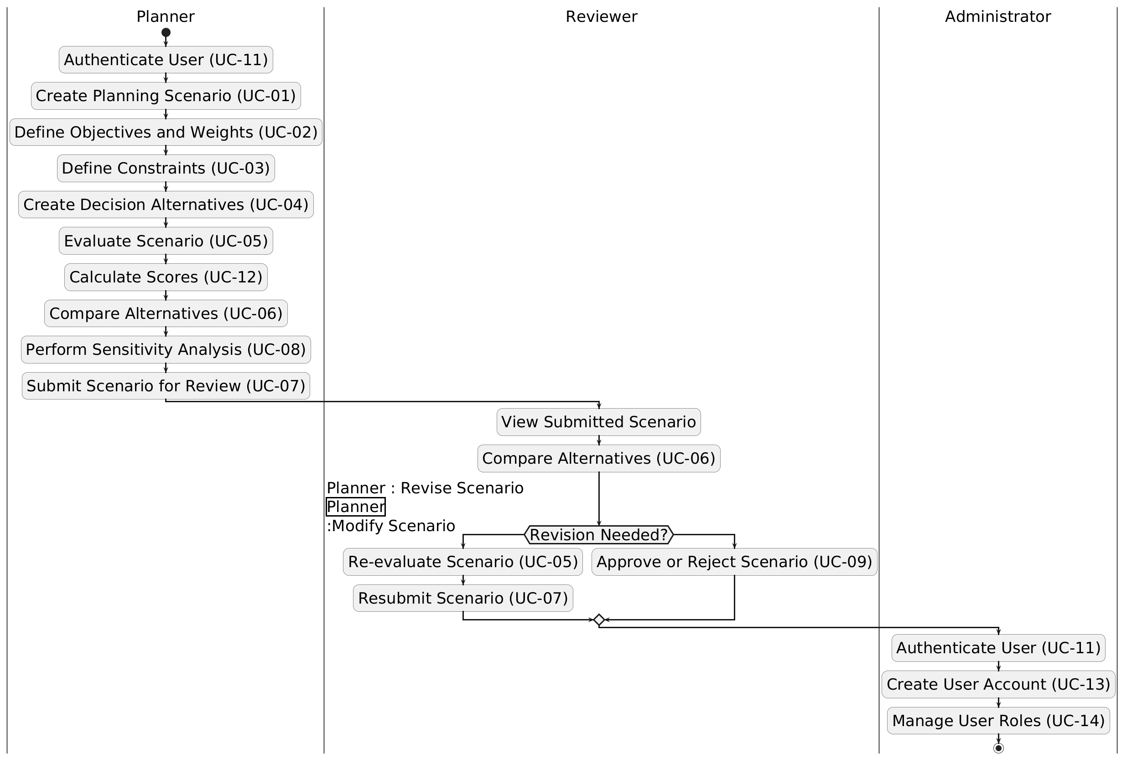

Diagram 3: Activity Diagram for “Multi-Objective Decision Support System for Business Planning”

